**ORDERING ONLINE FROM FONTINA GRILLE**

by

Ryan Gomez

WRTG 393 – Advanced Technical Writing

Professor Matthew Hodgman

University of Maryland Global Campus

May 29th, 2023

**Introduction**

Ordering food online from a local restaurant has become a popular and convenient way for people to eat the food they love without leaving the comfort of their homes. With the rise of the internet and online platforms, customers can view, select, customize, and set up delivery of their favorite dishes within just a few minutes of time and a few clicks on their phone, tablet, or computer with a mouse and keyboard. Ordering food online has become the go-to method of ordering takeout or delivery due to its convenience, variety, and ease of use. Ordering food online provides a seamless and efficient solution for individuals seeking a great dining experience without cooking at home or going to a restaurant.

**Instructions**

1. Order food online from the Fontina Grille restaurant.
   1. Go to[**https://www.fontinagrille.com**](https://www.fontinagrille.com) using the browser of your choice.

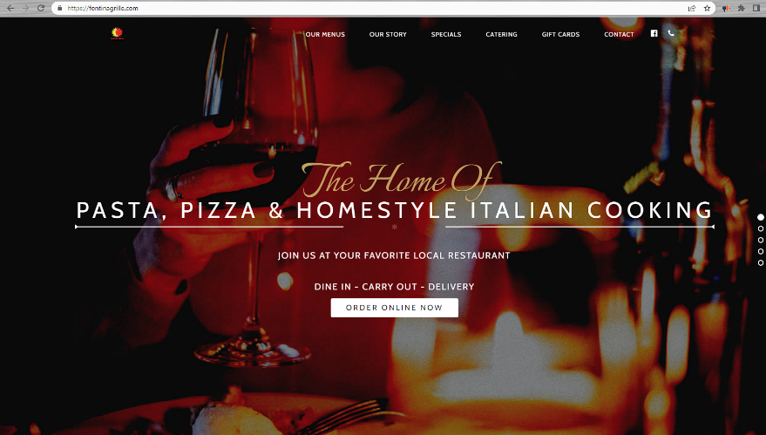

**Figure 1**

*Fontina Grille Website Landing Page*

Enter <https://www.fontinagrille.com> in your web browser of choice.

Note. Fontina Grille, n.d., [Screenshot] (https://www.fontinagrille.com)

* 1. Click on **ORDER ONLINE NOW**

**Figure 2**

*Fontina Grille Website Landing Page – Order Online Now*

Click on **ORDER ONLINE NOW**

Note. Fontina Grille, n.d., [Screenshot] (https://www.fontinagrille.com)

* 1. Click **ES** or **EN** to switch between the Spanish and English ordering and menu options.

**Note.** EN is the English option and ES is the Spanish option.

**Figure 3**

*Fontina Grille Food Order Page – Language Selection*

Click here to switch between (**EN**) English and (**ES**) Spanish

Note. Fontina Grille, n.d., [Screenshot]. (https://fontinagrille.hrpos.heartland.us/menu)

* 1. A picture containing text, screenshot, fruit, website

     Description automatically generatedSelect **BEGIN ORDER** to choose between delivery and carryout options.

**Figure 4**

*Fontina Grille Food Order Page – Begin Order*

**BEGIN ORDER** brings up the **CARRYOUT** and **DELIVERY** selection prompt.

Note. Fontina Grille, n.d., [Screenshot]. (https://fontinagrille.hrpos.heartland.us/menu)

* 1. Choose **CARRYOUT** or **DELIVERY** by clicking. If choosing **DELIVERY**, proceed to **Step 6**. If choosing **CARRYOUT**, click on **CARRYOUT** and then on **CONTINUE** and proceed to **Step 7**.

Note. When choosing CARRYOUT, there is no additional information required to be entered. After clicking CARRYOUT, click **CONTINUE** and proceed to **Step 7**.

**Figure 5**

*Fontina Grille Food Order Page – Delivery or Carryout*

**BEGIN ORDER** brings up the **CARRYOUT** and **DELIVERY** selection prompt.

Note. Fontina Grille, n.d., [Screenshot]. (https://fontinagrille.hrpos.heartland.us/menu)

* 1. Choose **DELIVERY** by clicking, then enter your address and any special instructions for your delivery driver.

**Figure 6**

*Fontina Grille Food Order Page – Delivery Options*

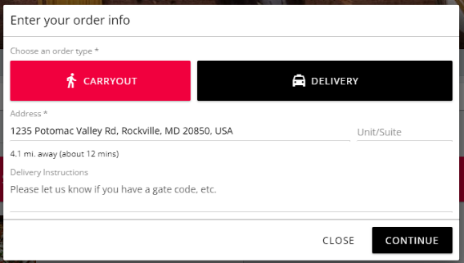

Choose **DELIVERY** and fill out delivery details including address and special instructions for the delivery driver.

Click **CONTINUE** when done entering delivery details.

Note. Fontina Grille, n.d., [Screenshot]. (https://fontinagrille.hrpos.heartland.us/menu)

* 1. Click on the menu item you want to order by scrolling up and down the menu and clicking on the item you are ordering.

**Figure 7**

*Fontina Grille Food Order Page – Menu*

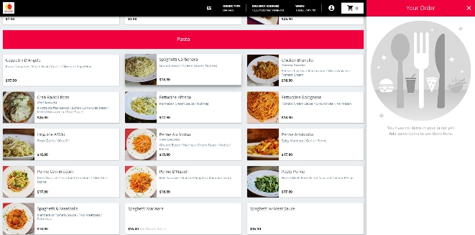

Scroll up and down the menu using the ARROW keys on the keyboard, scroll wheel on the mouse, or by dragging your finger up or down on a touch enabled device.

Click on a menu item to select it.

Note. Fontina Grille, n.d., [Screenshot]. (https://fontinagrille.hrpos.heartland.us/menu)

* 1. Customize the menu item you selected by choosing from the available options. Click on the empty box next to each option you want to add. Click on **ADD TO ORDER** once all the choices for this item are complete and add the item to the cart.

**Warning: Food allergies: Any food allergies or special requests should be entered in the special instructions section on each item ordered.**

**Note 1**. The item shown here includes options for an included side, protein addons, and alternative pasta options.

**Note 2**. When ordering for large groups of people, enter the intended recipients name in the “Who is this item for?” field.

**Figure 8**

*Fontina Grille Food Order Page – Menu Item Customization*

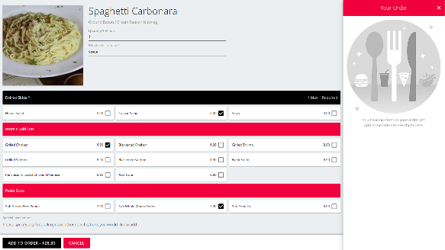

Note 2: Add the name of the person for which this item is intended.

Note: 1 Choose options, addons, and substitutions here.

**Warning: Add any food allergies or special requests here.**

Click **ADD TO ORDER** when all customization is complete.

Note. Fontina Grille, n.d., [Screenshot]. (https://fontinagrille.hrpos.heartland.us/menu)

* 1. Repeat **Steps 7 and 8** until all items to be ordered are added to the cart.
  2. Edit or remove an item from the cart. Click on the pencil icon next to the item you wish to edit or remove (Figure 9). If removing an item, click on **REMOVE** (Figure 10).

Note. Proceed to **Step 11** once you no longer need to edit items or remove items from the cart.

**Figure 9**

*Fontina Grille Food Order Page – Viewing Cart*

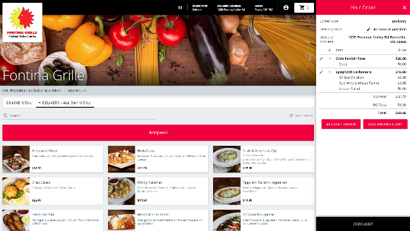

Click on the pencil icon next to the item you want to edit or remove.

Note. Fontina Grille, n.d., [Screenshot]. (https://fontinagrille.hrpos.heartland.us/menu)

**Figure 10**

*Fontina Grille Food Order Page – Edit or Remove Item from Cart*

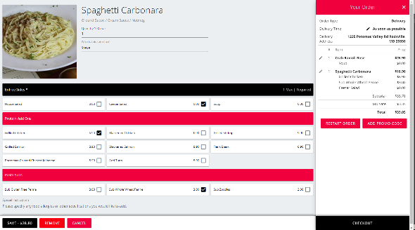

Change any options here as in Step 8 to edit the item.

Remove the item by clicking REMOVE.

Save the changes to the item by clicking SAVE.

Note. Fontina Grille, n.d., [Screenshot]. (https://fontinagrille.hrpos.heartland.us/menu)

* 1. Click on **CHECKOUT** to complete the menu item selections.

**Figure 11**

*Fontina Grille Food Order Page – Cart Checkout*



Click on **CHECKOUT** when all desired items are in the cart and you are ready to provide payment details.

Note. Fontina Grille, n.d., [Screenshot]. (https://fontinagrille.hrpos.heartland.us/menu)

* 1. Enter your information and choose your payment type (Credit Card or Gift Card). If using a credit card proceed to **Step 13**. Gift Cards proceed to **Step 14**.

**Figure 12**

*Fontina Grille Food Order Page – Delivery or Carryout*

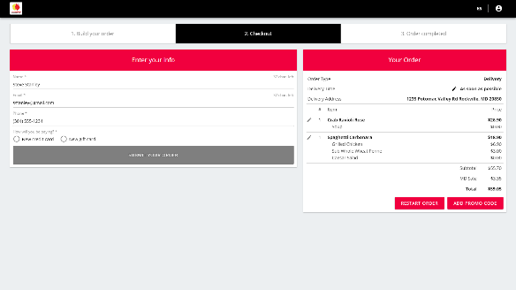

Enter your name, email address, and phone number here.

Choose your payment option here.

Note. Fontina Grille, n.d., [Screenshot]. (https://fontinagrille.hrpos.heartland.us/menu)

* 1. Enter your credit card information and click **ADD CARD**.

**Figure 13**

*Fontina Grille Food Order Page – Credit Card Payment*

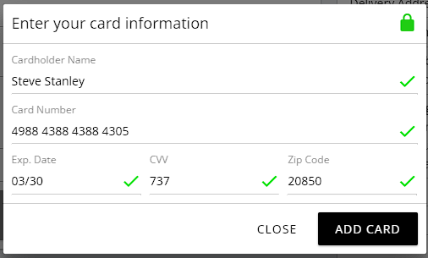

Enter your credit card information including cardholder name, card number, expiration date, security code, and the card’s billing zip code.

Click on **ADD CARD** to add the payment information to your order.

Note. Fontina Grille, n.d., [Screenshot]. (https://fontinagrille.hrpos.heartland.us/menu)

* 1. Enter your gift card information and click **ADD CARD**.

**Figure 14**

*Fontina Grille Food Order Page – Gift Card Payment*

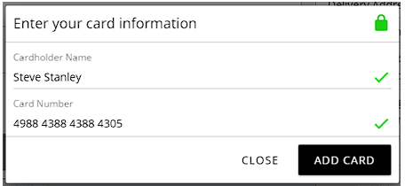

Enter the information for your gift card.

Note. Fontina Grille, n.d., [Screenshot]. (https://fontinagrille.hrpos.heartland.us/menu)

* 1. Enter the desired tip amount and click **SUBMIT YOUR ORDER**.

**Figure 15**

*Fontina Grille Food Order Page – Tip and Submit Order*

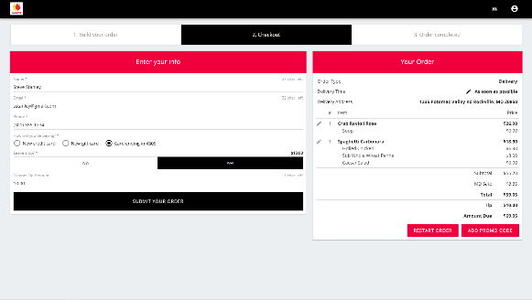

Choose tip amount.

Click on **SUBMIT YOUR ORDER**.

Note. Fontina Grille, n.d., [Screenshot]. (https://fontinagrille.hrpos.heartland.us/menu)

* 1. Open your email and check to confirm you have received your emailed receipt and order confirmation.

**Note**. Order confirmation emails will come from [noreply-hrpos@heartland.us](mailto:noreply-hrpos@heartland.us). This email may end up in your junk/spam folder.

**Figure 16**

*Email – Order Confirmation*

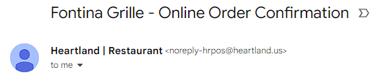

Note. Gmail, n.d., [Screenshot]. (https://www.gmail.com)

1. Order a gift card online from the Fontina Grille restaurant.
   1. Go to[**https://www.fontinagrille.com**](https://www.fontinagrille.com) using the browser of your choice.



**Figure 17**

*Fontina Grille - Landing Page*

Enter <https://www.fontinagrille.com> in your web browser of choice.

Note. Fontina Grille, n.d., [Screenshot]. (https://www.fontinagrille.com)

* 1. Click on **GIFT CARDS**.

**Figure 18**

*Fontina Grille Food Order Page – Delivery or Carryout*

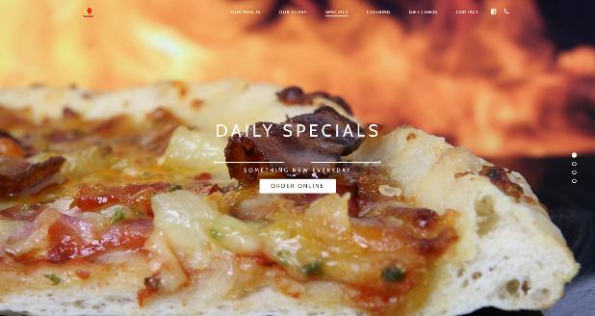

Click on **GIFT CARDS**.

Note. Fontina Grille, n.d., [Screenshot]. (https://www.fontinagrille.com)

* 1. Click on the **DENOMINATIONS** drop down menu, choose your gift card amount, and click on **ADD TO CART**.

**Figure 19**

*Fontina Grille – Gift Card Selection*

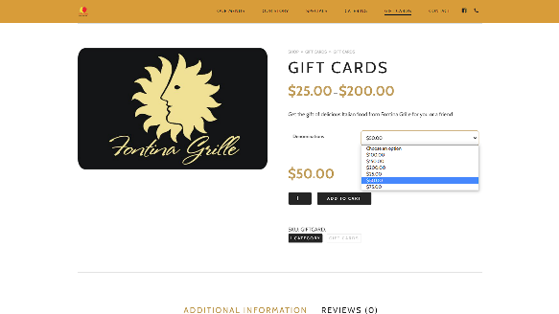

Click on the **DENOMINATIONS** drop down and select the gift card amount you want to purchase.

Click **ADD TO CART.**

Note. Fontina Grille, n.d., [Screenshot]. (https://www.fontinagrille.com)

* 1. Repeat **Step 2** for any additional gift cards desired. Click on **VIEW CART** once all the desired gift cards have been added.

**Figure 20**

*Fontina Grille – Gift Card Selection and View Cart*

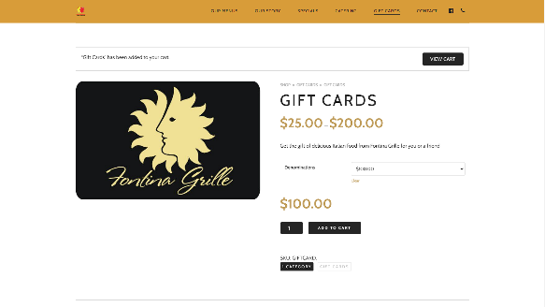

Click on **VIEW CART** once all desired gift cards have been added to the cart.

Note. Fontina Grille, n.d., [Screenshot]. (https://www.fontinagrille.com)

* 1. Verify the quantity of gift cards is correct and click on **PROCEED TO CHECKOUT**.

**Figure 21**

*Fontina Grille – Gift Card Cart*

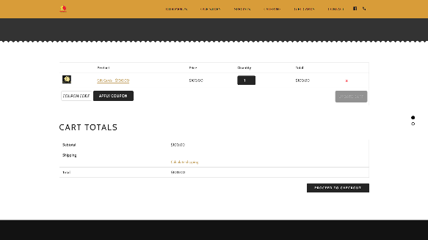

Verify quantity and amounts of gift cards.

Click on **PROCEED TO CHECKOUT**.

Note. Fontina Grille, n.d., [Screenshot]. (https://www.fontinagrille.com)

* 1. Enter all payment and shipping information and click on **PLACE ORDER**. Information for this step is displayed in Figures 21 and 22.

**Note**. Shipping information is only required if you want the gift card to be mailed to a recipient. Otherwise, the gift card will be available to be picked up from the restaurant after an online purchase.

**Figure 21**

*Fontina Grille Food Order Page – Payment and Shipping Details*

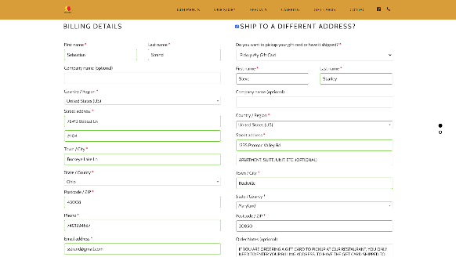

Note. Fontina Grille, n.d., [Screenshot]. (https://www.fontinagrille.com)

Enter all payment information on the left column.

Enter all shipping information on the right column.

**Figure 22**

*Fontina Grille Food Order Page – Final Payment Details and Order Placement*

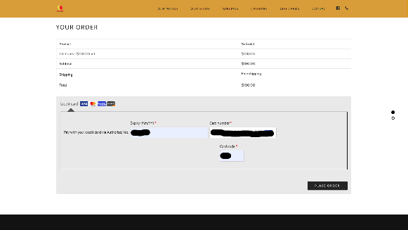

Note. Fontina Grille, n.d., [Screenshot]. (https://www.fontinagrille.com)

Enter credit card details here.

Click on **PLACE ORDER**.

**Accommodation of the Three Persona’s Pain Points**

Each of the personas have different pain points that need to be addressed in the instructions on ordering food from Fontina Grille. First, Michael O’Donnell has coworkers with special dietary and food allergy considerations that need to be addressed. In Step 8 on ordering food from Fontina Grille, the instructions provide information on how to label each item for a specific recipient and where to put information about food allergies and special requests to alert the restaurant’s staff. Step 8 also included a warning callout to ensure that Michael enters any food allergies or special orders at this point in the ordering process. The next persona, Sebastian Strand wanted to order a gift card for his brother that has a sick child in the hospital. It is important that Sebastian’s brother can receive the gift card in the mail, as Sebastian lives in another state. In Step 6 on how to order gift cards from Fontina Grill online, the instructions include where to enter shipping information for gift cards. Finally, the third persona, Milagros de la Cruz does not read and write in English very well. For Milagros, having a Spanish option is very important. Step 3 on ordering food from Fontina Grille gives instructions on switching between Spanish and English. The three personas all had unique pain points and the instructions addressed each of these challenges for them.